**Online Loan Application and Verification for Personal Loan**

**ABSTRACT*:*** Online loan application is a project developed to provide an easy way to apply loan. Users can get information about applying loan and can apply online. By using this application user’s can save lot of time. Users need to fill the details of identity cards like PAN and bank account details. All the user’s details will be verified by the bank authority and status of loan. User can get notification regarding loan whether approved or rejected. Users can download the details of the loan after approved. User can apply get all the information about the loan from anywhere and at anytime.

**KEYWORDS**: CIBIL(credit Information Bureau India Limited),Documents,Status,Verification

# INTRODUCTION

The portal has 3 user types namely Loan Applicant or Customer and the Loan Verification officer of the bank and CIBIL officer. The security and data privacy is at the core of the design of the portal, data can be accessed only be registered users and they can only access data that is relevant to them. The authenticated applicant will get access to the Loan Application Form which includes several fields like loan amount expected, value of the supporting documents, age, gender, address, if there are any previously existing loans and the liability remaining in existing loans. If Applicant is accessing the portal the first time, then he/she should enter the complete details in the user Registration page.

The Loan requests submitted by the applicants will be viewed by the Verification officer from the bank, they go through all the details including the supporting documents. Once the officer verifies the CIBIL link and they provide score once credit details in other banks, the officer will approve the loan application. If the details are found not matching the officer can reject the application. All the status updates will be notified to the concerned users through email.

To design and develop smart online loan application and verification system for PKGB by eliminating the manual process by completely digitising the system. The customer can register loan in this banking system only if we have credit account in same bank.The loan approval process is done only for registered customers .The personal loan application and verification is done through CIBIL report verification with CIBIL score.The customer must login with email-id and password.It is only limited to initial stage of online approval of documents by admin.The customer can login and get approval status only through website.

# LITERATURE SURVEY

A loan is a amount of money given to an individual or institution on the condition that it will be paid back over a given period with interest, with serves as payment for the use of money there are various types of loans such as credits, finance, and mortages.

The manual process of obtaining and granting loans is stressfull, inconvenient and time wasting for lender and borrower as well. There is a need to automate the loan processing procedure as much as possible. The goal of this project is, therefore, to design and create loan automation application software that can capture the required loan data elements only once, keep such information secure throughout the loan process, convert the previous hand to hand system of obtaining and granting loans into a computerized less stressfull form, keep track of individuals in the process, monitor and track loans given out to allow better flow and enhance compliance to conditions, ensure security of information reduce lending life cycle times,apply appropriate interest to loans and notify the concerned individual on the progress of their loan.

This paper mainly contains the loans management system was developed specifically many of the banks give loans for manually by this paper I introducing the new concept for online loans services. Now coming to paper we creating the security provided by who are having already account in that particular bank. The user have to take the one time password then user take the online loan in any where in particular regions. This idea is very use full for the all educated users, now we all are uses the ATM. Why we can provide the Security? For purpose of intruder does not allow this system. Because the intruder does not know the correct password and correct user name. In this security provides to the each and every banking services. User receives the username and password by email or SMS. The user get the loan money by ATM..

# EXISTING SYSTEM

The existing system is a manual system which doesn’t maintain details with proper security and takes lot of time in verification of the documents. It is not a user friendly interface. It does allow users to check their profile and will not provide proper information about the loan process. It takes lot of time to the bank authority to manage customer information. It required more paper work.

# EXPERIMENTAL RESULTS

1. **User management**

Registration: Customer can register with basic information like user name ,mobile number,Email-Id etc... Login: Admin, User can login with user name & password.

Manage profile: Admin, user can manage profile and update information.

# Loan Application:

Admin manage loan application which is sent by customer using the system.User provides all necessary details like loan type, interest rate etc.

# Supporting document for uploading verification:

The required customer details like loan type, loan interest ,surety for personal loans are verified .

# CIBIL Verification:

The PAN number of customer is used for getting CIBIL report where it gives details of one’s debt accounts and their payments in other banks.

# Loan approval and status updation:

Once the documents are verified by admin the documents submitted by customers found genuine the loan is approved and status is updated if not the loan approval is rejected.

# PROPOSED SYSTEM

The proposed system provides an easy way to users in applying loan. Users can apply for a loan from anywhere and at anytime and get notifications. Users can view their profile details and can view all the details of the loan. System provides download option to download different type of loan form in MS word document. Using this system bank authorities can find users details easily .This system is a paperless system by which workload is reduced.

# SYSTEM ARCHITECTURE AND DESIGN

**System Architecture** is the functional model that describes the structure, conduct, and more perceptions of a framework. An engineering depiction is a formal portrayal and illustration of a framework, sorted out in a way that thinksabout the structure of the architecture which involves framework segments, the connections (e.g. the behavior) amongst them,and gives a platform from where the items can be attained, and frameworks built up, that will cooperate to actualize theuniversal framework.

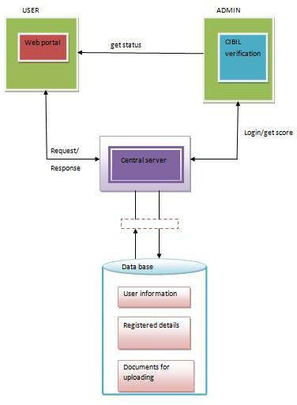

Fig 6.1:system architecture

# EVALUATION AND RESULTS

* 1. **loan application and verification**

The project online loan application and verification system has two use types, one is for customers and other is bank employee. The system works with two API’s server script for handling front end with java, JSP and another one API backend with MySQL this is for handling database logic and business communication of loan application system.

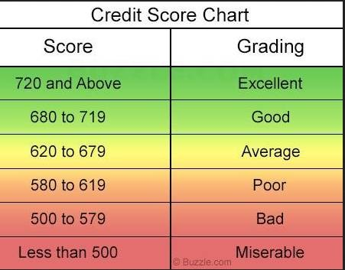

Fig 7.1 credit score chart

The customer will be able to login into the system after self registration. once the registration is successful the customer can apply for loan online via the system. This reduces the hassle for the customers. Once after the submission of loan details is successful, It will be processed further by verifying the details through CIBIL scores and PAN details by the bank employee. After all details being verified and found valid the loan will be approved by bank employee else the loan will be rejected.finally the status of the loan can be checked by the customer by logging into the website with valid user credentials.

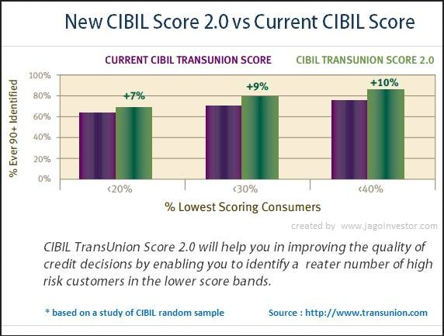

Fig 7.2:CIBIL verification improvement ratio

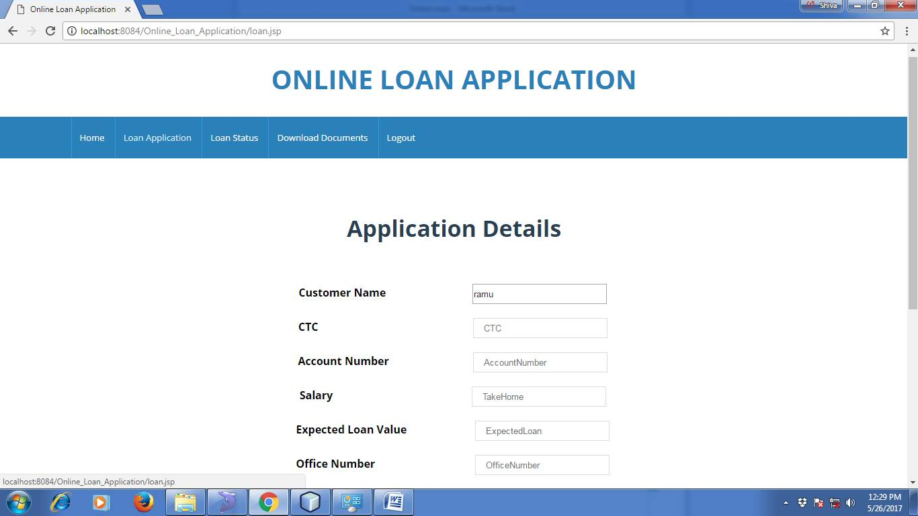

Fig 7.3:customer login into the web portal for loan application

* 1. **advantages of proposed system**
     + To provide a good interaction and communication facilities between customer and administrator.
     + To provide online back office activities of bank which offers for Personal loan.
     + To manage customer information data base efficiently through administrator.
     + To provide facility to generate the reports about loan approval status with the help of CIBIL report very easily.
     + Reduces the paper work and time consumed in submission and verification of loan request.